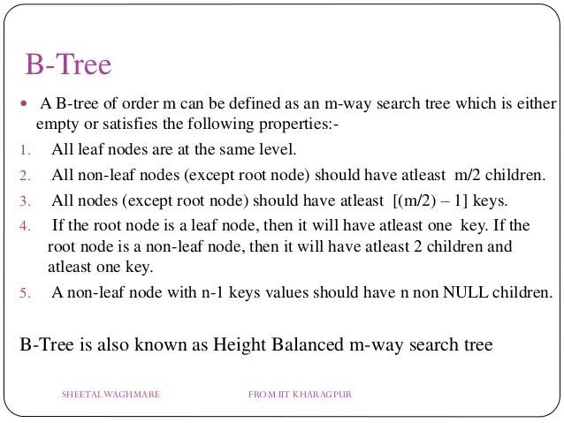

Where M is the order

**Listed below are some of the properties of B-Tree.**

* All leaves of B-tree are at the same level.
* **A B-tree of order m can have at most m-1 keys and m children**.
* **Every node in B-tree has at most m children.**
* **Root node must have at least two nodes.**
* **Every node except the root node and the leaf node contain** **m/2 children.**

Next, we discuss some of the basic operations of B-tree.

The most important difference between B-tree and B+ tree is that B+ tree only has leaf nodes to store data, and other nodes are used for indexing, while B-trees have Data fields for each index node.

1. In a B tree search keys and data stored in internal or leaf nodes. But in B+-tree data store only leaf nodes.
2. Full scan in a B+ tree is very easy because all data are found in leaf nodes. Full scan a B tree requires a full traversal.
3. In a B tree, data may be found in leaf nodes or internal nodes. Deletion of internal nodes is very complicated. In a B+ tree, data is only found in leaf nodes. Deletion of leaf nodes is easy.
4. Insertion in B tree is more complicated than B+ tree.
5. **B+ trees store redundant search key but B tree has no redundant value.**
6. **In a B+ tree, leaf nodes data are ordered as a sequential linked list but in B tree the leaf node cannot be stored using a linked list. Many database systems' implementations prefer the structural simplicity of a B+ tree.**

